CloudWatch and SNS

1.Create a dashboard with few metrics using cloudWatch and share with others?

Ans:- 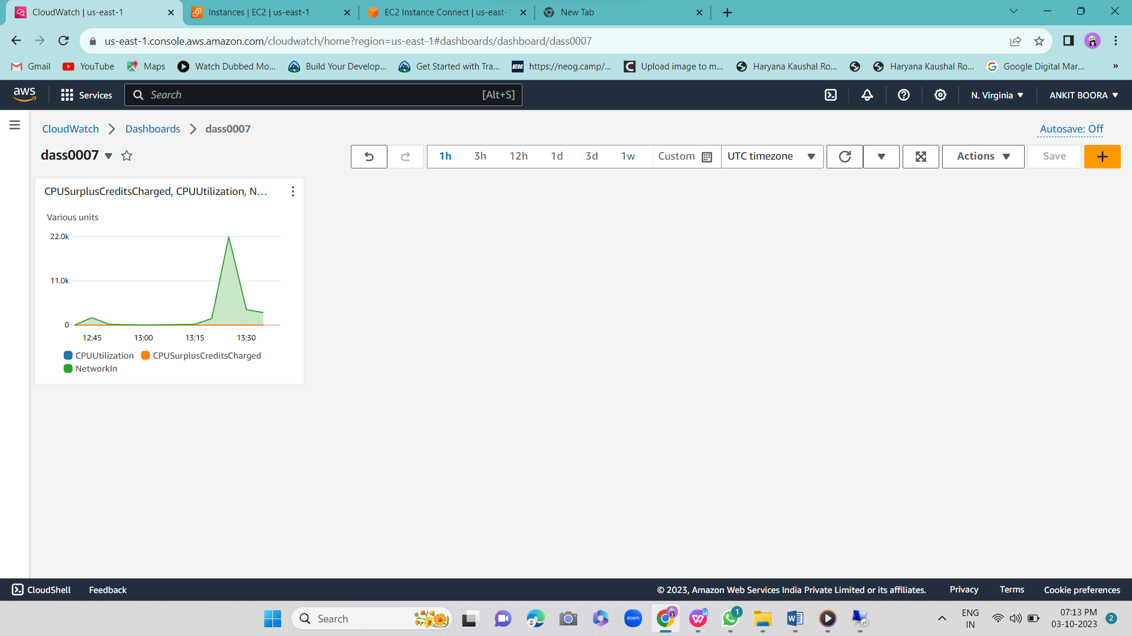

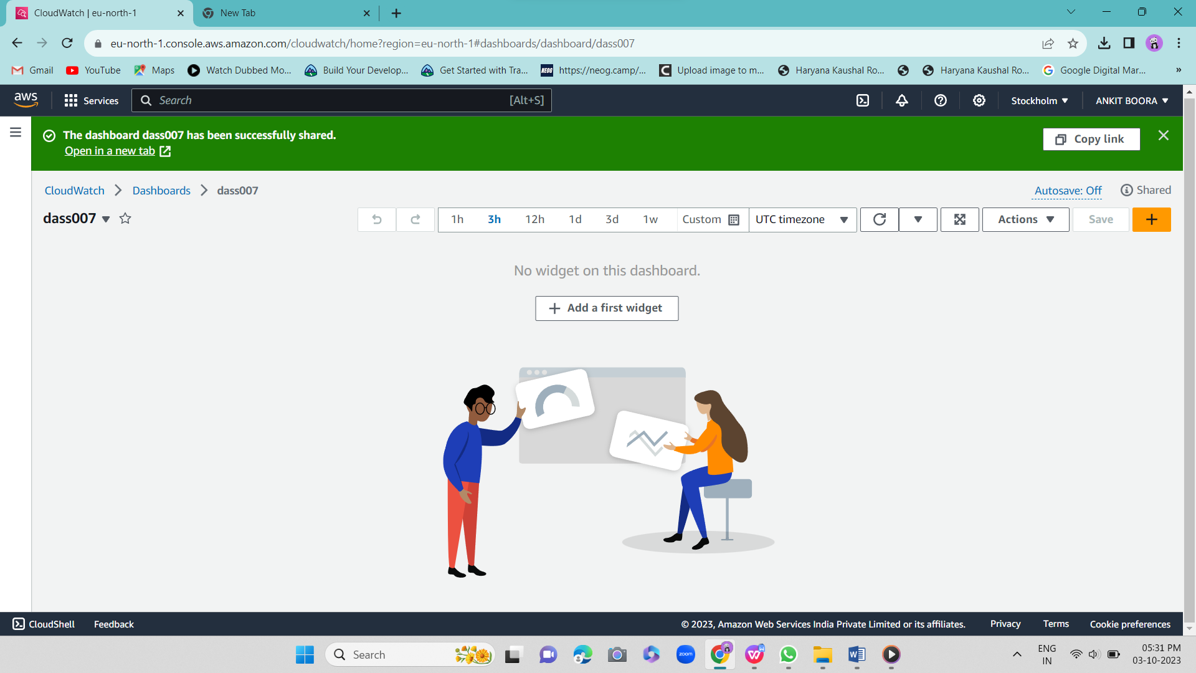

2.Create an alarm in CloudWatch for CPU utilization metrics for an ec2 instance?

Ans:- 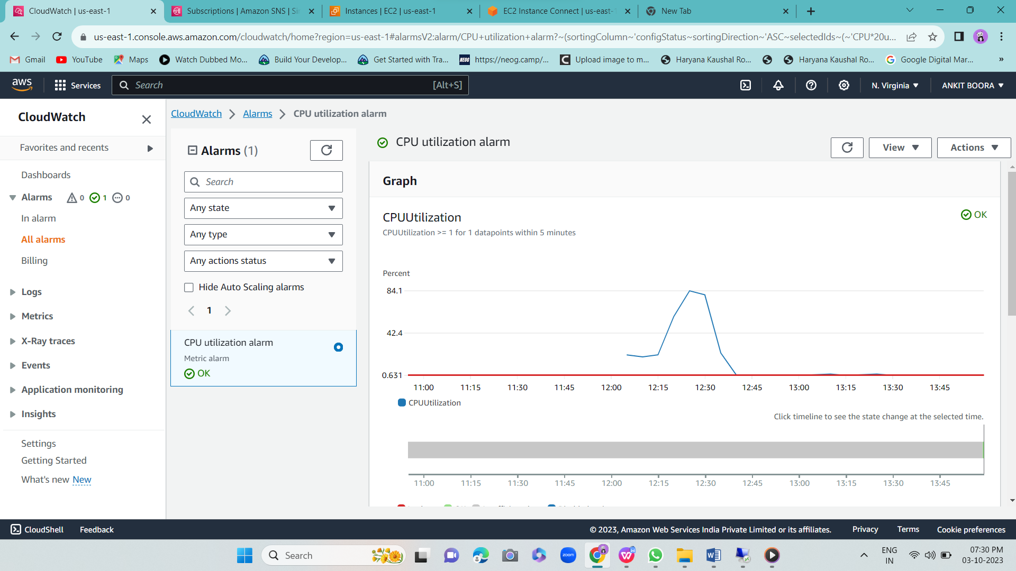

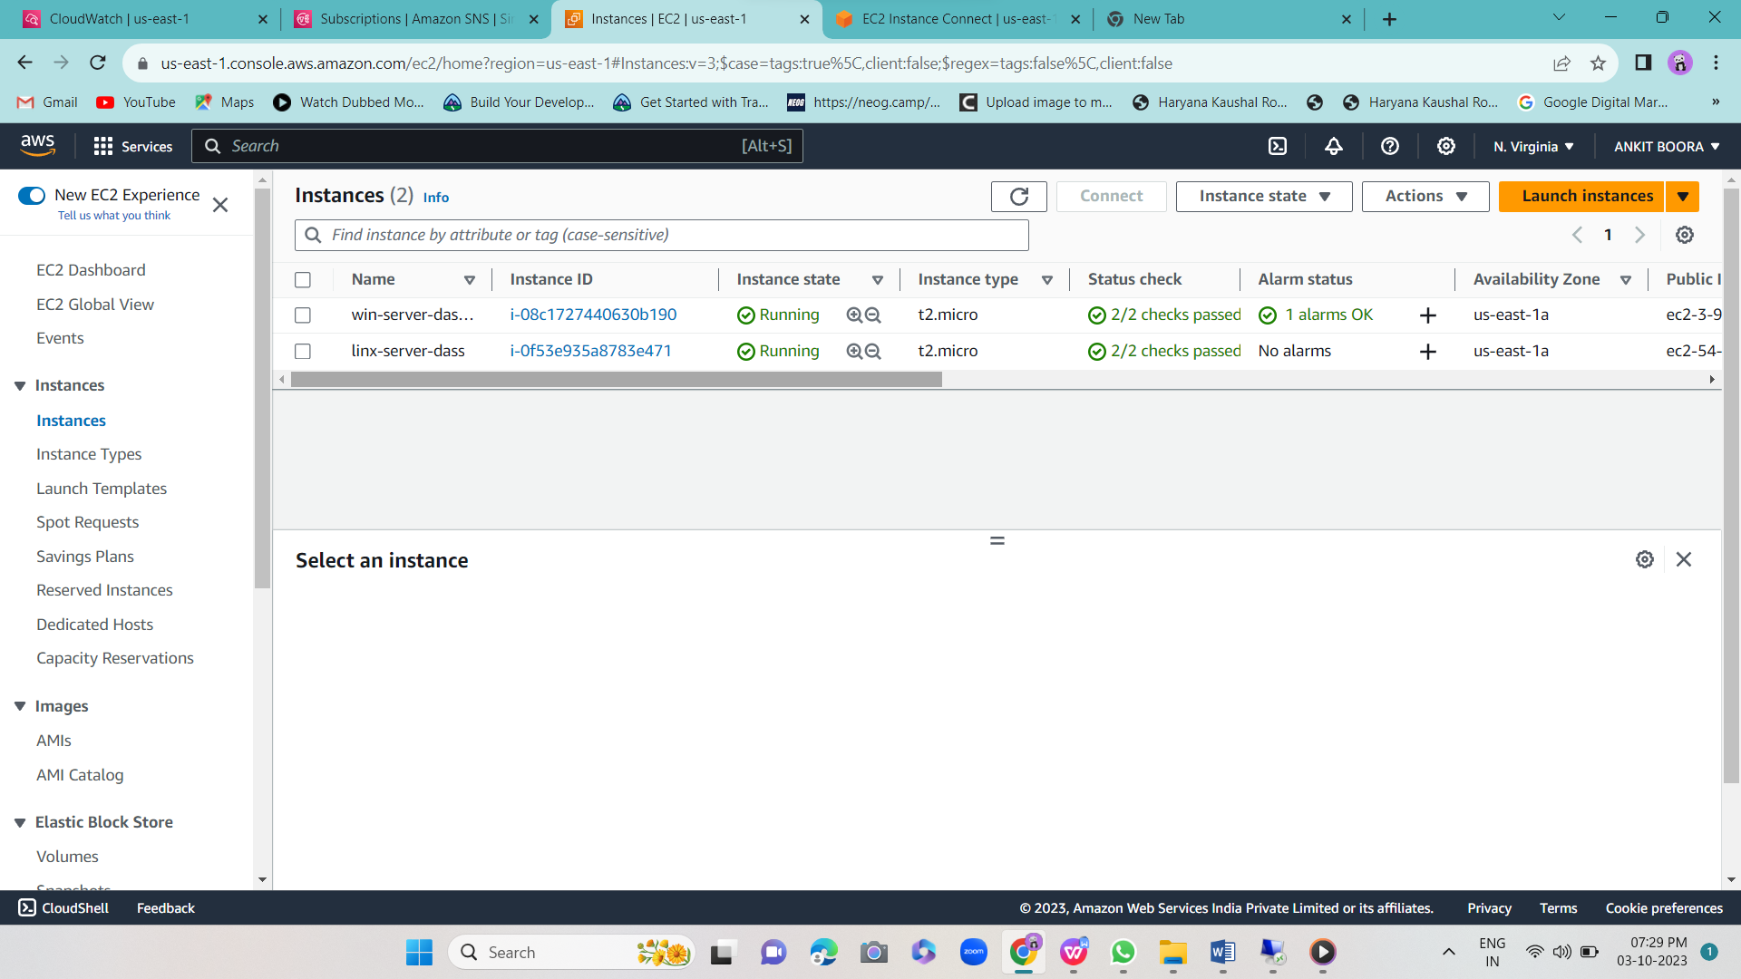

3.Create a topic and a subscription in SNS with Email protocol?

Ans:- 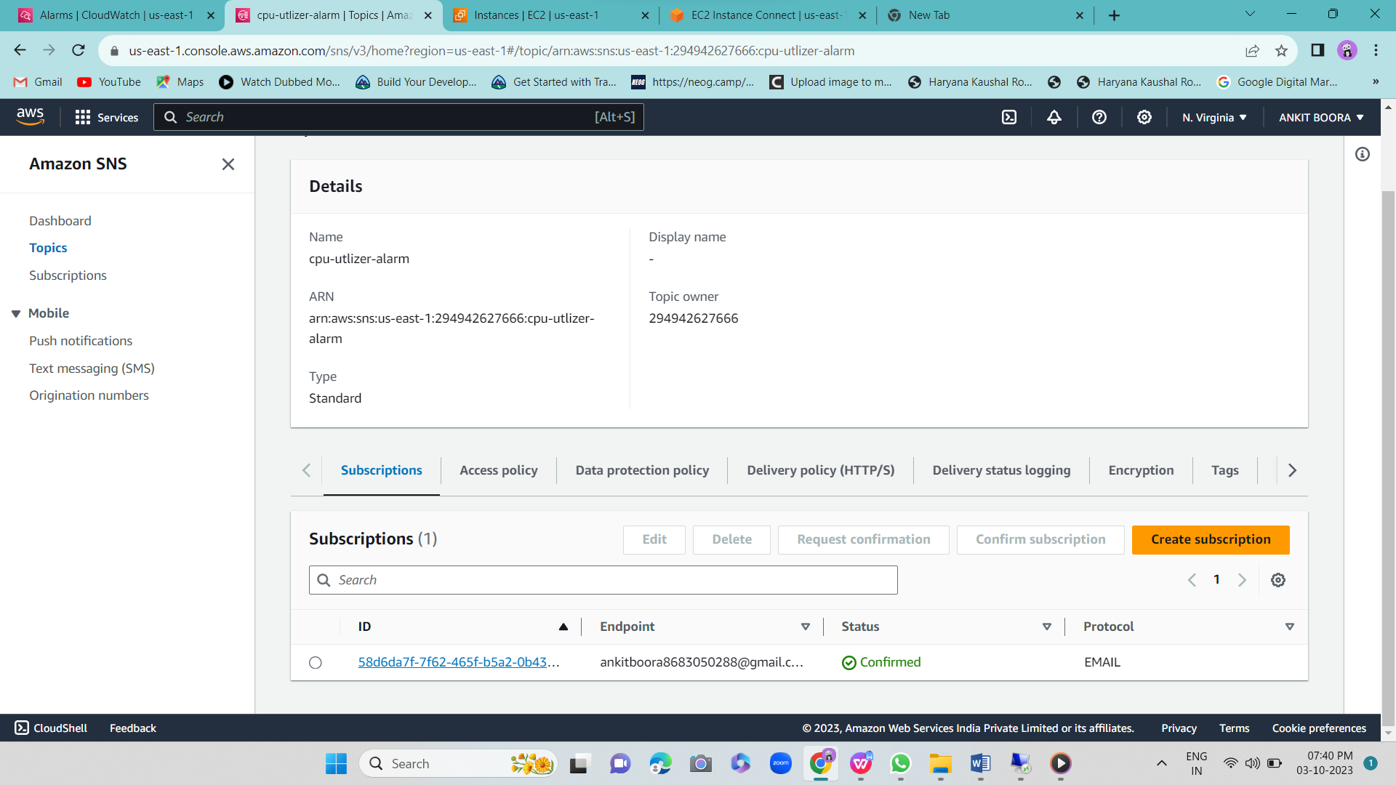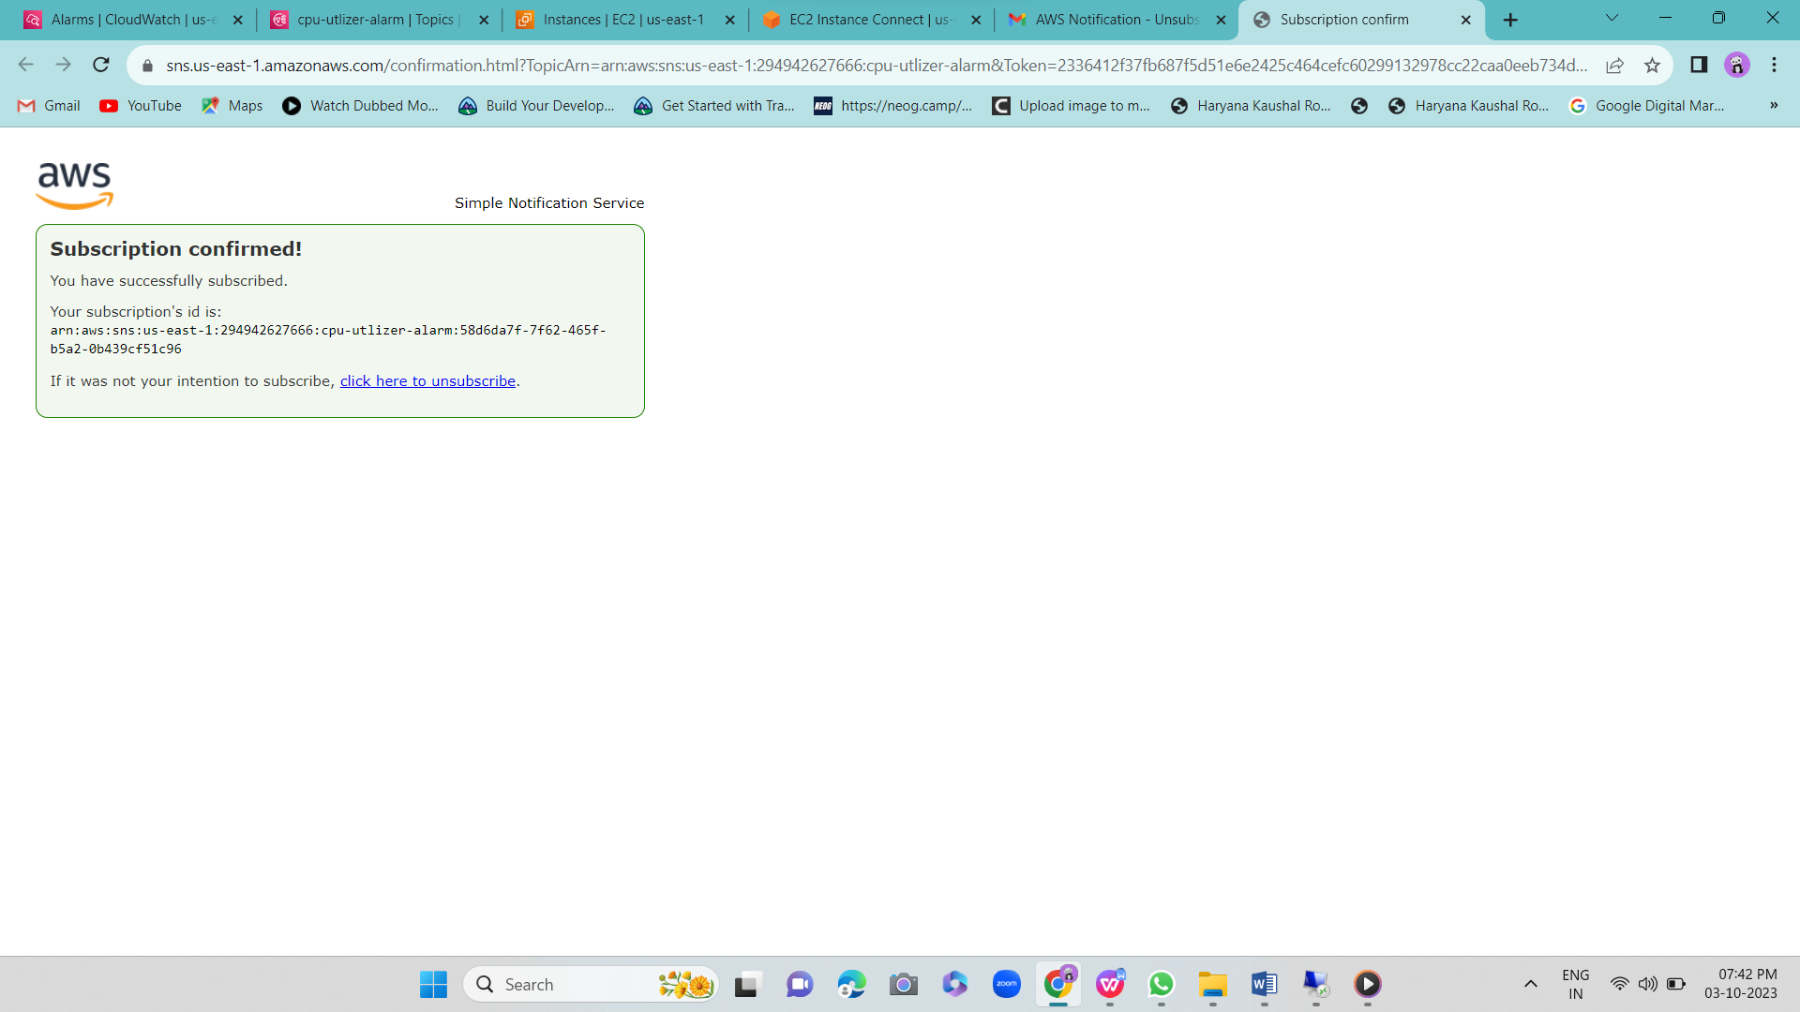

4.Implement CloudWatch with Agent and System Manager?

Ans:-

